***Deliverable 4 Final Report***

***SEG2105 - Introduction to Software Engineering***

***Fall 2018***

***School of Electrical Engineering and Computer Science***

***University of Ottawa***

***Course Coordinator: Dr. Miguel A. Garzón***

***Due Date: Dec 5th***

***Student 1: Xumou Zhang 8474153***

***Student 2: Mingwei Deng 7847379***

***Student 3: Dengyu Liang 300019847***

***Student 4:Yuxuan Jiang 8235509***

***Student 5: Jichao An 8300233***

Short Introduction:

In this project, we build a Service program for the service providers and home owners, also build administers as the regulars for the users. We use the firebase as the database to keep the data.

All 5 members were participated in parts of the project programming or report writing.

Lesson Learned:

In this project, we learned that:

1. Do not use firebase when we are unfamiliar with it, because we had a really bad time to debug the firebase parts.
2. When everyone is doing the work, it is important to separate the files that need to be accessed or to be changed because we are working with Github which is easy to create conflicts between two people’s workloads.
3. It is also important for the group leader to not only separate the workloads to everyone, but also supervise and urge everyone to finish their works. A group will fail to finish the work before the deadline if a group leader fail to do that.
4. It is important to search on the professional website for solution which we faced.
5. Ask for help when the person cannot figure out the problem.

Table with the roles in the team and contributions of team members for each deliverable:

|  |  |  |  |  |  |
| --- | --- | --- | --- | --- | --- |
|  | Deliverable 1 | Deliverable 2 | Deliverable 3 | Deliverable 4 | All members participated in writing java codes from d1 to d4. |
| ***Xumou*** | 22% | 20% | 21% | 17.5% | Responsible for all umls and final reports. |
| ***Mingwei*** | 22% | 20% | 24% | 20% | Responsible for all unit tests and circle ci |
| ***Dengyu*** | 22% | 23% | 22% | 22.5% | Responsible for most of Firebase. |
| ***Jichao*** | 12% | 12% | 12% | 20% | Responsible for parts in 1,2,3 and did more on p4 |
| ***Yuxuan*** | 22% | 25% | 21% | 20% | Responsible for all xmls |

UML Diagrams and UML codes for deliverable 1,2,3 and 4:

Deliverable 1 UMPLE Code:  
class Login  
{  
 String username;  
 String password;  
}  
  
class Account  
{  
 * -- 1 Login;  
 String username;  
 String password;  
   
 1 -- 1 User;  
}  
  
class User  
{  
 String lastName;  
 String firstName;  
 Date dateOfBirth;  
   
 String email;  
 String phoneNum;  
 String address;  
   
}  
  
class Administrator  
{  
 isA User;  
}  
  
class Service_Provider  
{  
 isA User;  
}  
  
class Homeowner  
{  
 isA User;  
}  
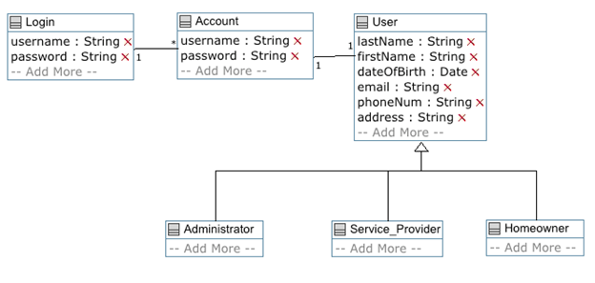  
 

Deliverable2:  
The administrator can:   
1. Create services (at least 10) to be offered: The list of services may include: Appliance install, carpet cleaning, moving, plumbing, appliance repair, Furniture assembly, Locksmith, painting, window cleaning, Electrical, Mould Remediation, Pest control, Junk Removal, Handyman services.   
2. Specifies a rate per hour for the services created.  
  
Code:  
class Login  
{  
 String username;  
 String password;  
}  
  
class Account  
{  
 * -- 1 Login;  
 String username;  
 String password;  
   
 1 -- 1 User;  
}  
  
class User  
{  
 String lastName;  
 String firstName;  
 Date dateOfBirth;  
   
 String email;  
 String phoneNum;  
 String address;  
   
}  
  
class Administrator  
{  
 isA User;  
}  
  
class Service_Provider  
{  
 isA User;  
}  
  
class Homeowner  
{  
 isA User;  
}  
  
class Service  
{  
 String serviceId;  
 String typeOfService;  
 double hourRate;  
 * -- 1..* Administrator;  
}  
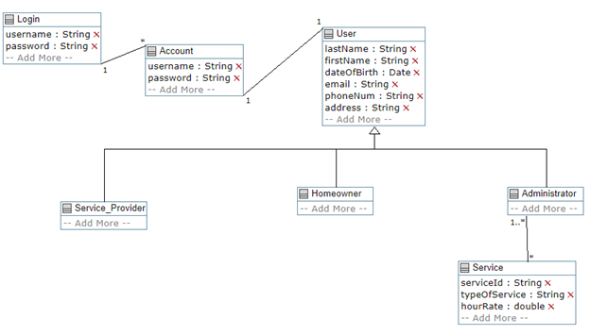

D3:  
class Login  
{  
 String username;  
 String password;  
}  
  
class Account  
{  
 * -- 1 Login;  
 String username;  
 String password;  
   
 1 -- 1 User;  
}  
  
class User  
{  
 String lastName;  
 String firstName;  
 Date dateOfBirth;   
   
 String email;  
 String phoneNum;  
 String address;  
   
}  
  
class Administrator  
{  
 isA User;  
}  
  
class Service_Provider  
{  
 isA User;  
}  
  
class Homeowner  
{  
 isA User;  
}  
  
class Service  
{  
 String serviceId;  
 String typeOfService;  
 double hourRate;  
 * -- 1..* Administrator;  
}  
class Profile  
{  
 String address;  
 String phoneNum;  
 String companyName;  
 String generalDescription;  
 boolean licensed;  
   
 String[] availabilityTimes;  
 1 -- 1 Service_Provider;  
 1 -- * Service;  
 }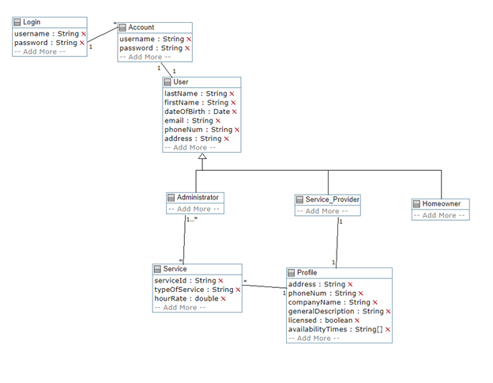

D4:

class Login

{

String username;

String password;

}

class Account

{

* -- 1 Login;

String username;

String password;

1 -- 1 User;

}

class User

{

String lastName;

String firstName;

Date dateOfBirth;

String email;

String phoneNum;

String address;

createUser(){}

}

class Search{

1 -- * Service;

Service_Provider searchByRate(int rating)

{

}

Service_Provider searchByTime(Time time)

{

}

Service_Provider searchByType(Service service)

{

}

}

class Administrator

{

isA User;

void createService(Service service){}

void setRateOfService(int rate,Service serivce){}

removeService(Service service){}

editeService(Service service){}

}

class Service_Provider

{

isA User;

int rating;

void createProfile(String add,String phoneNum,String comNam, String genDes,bool lic,String[] availTimes){}

addServiceToProfile(Service service){}

removeServiceFromProfile(Service service){}

List getTimelist(){}

void addAvail(){}

}

class Homeowner

{

isA User;

void bookService(Time time){}

void rateService(int rating, Service service){}

* -- 1 Search;

}

class Service

{

String serviceId;

String typeOfService;

double hourRate;

* -- 1..* Administrator;

}

class Data{

String id;

Data data;

* -- 1 Firebase;

}

class Firebase{

vector dataList;

void pushData(Data data){}

Data getData(String id){}

}

class Profile

{

String address;

String phoneNum;

String companyName;

String generalDescription;

boolean licensed;

String[] availabilityTimes;

1 -- 1 Service_Provider;

1 -- * Service;

}

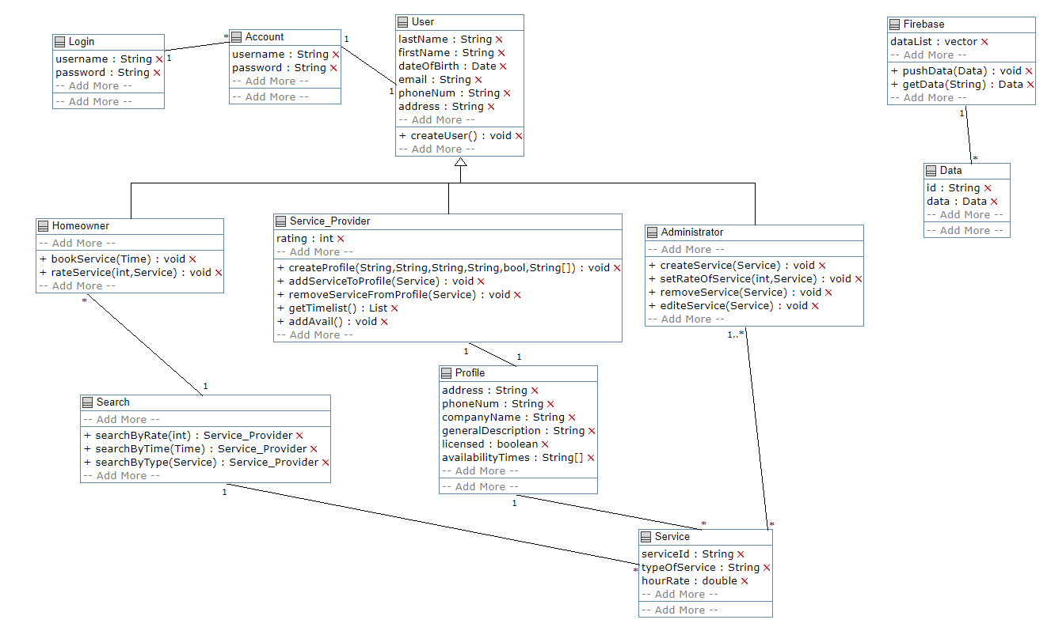

All the screenshots of our app: (Description in the end)

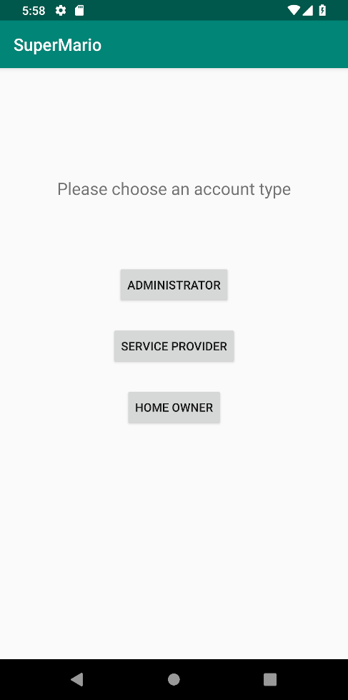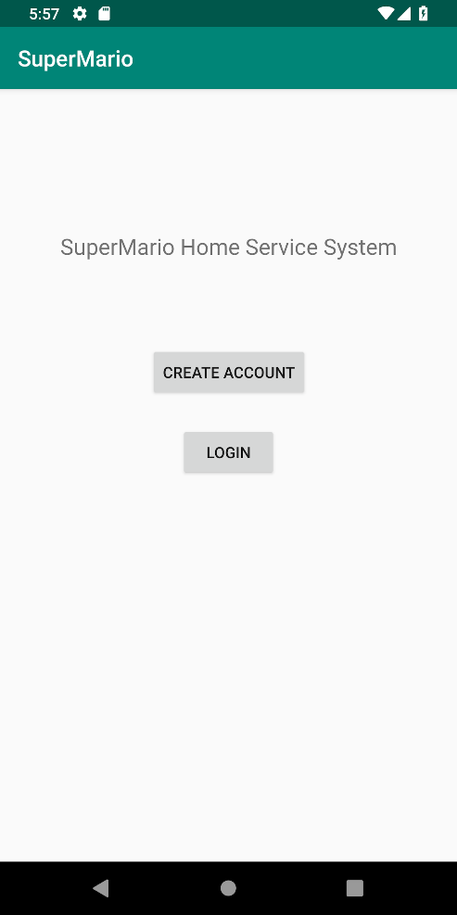

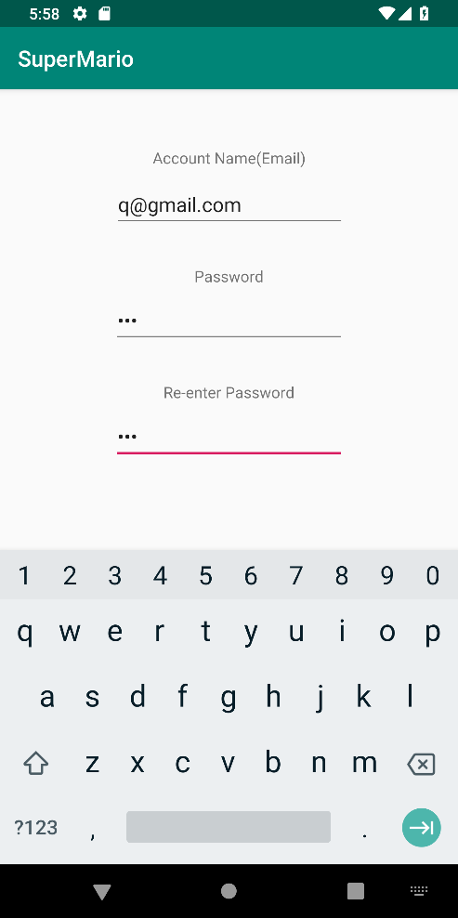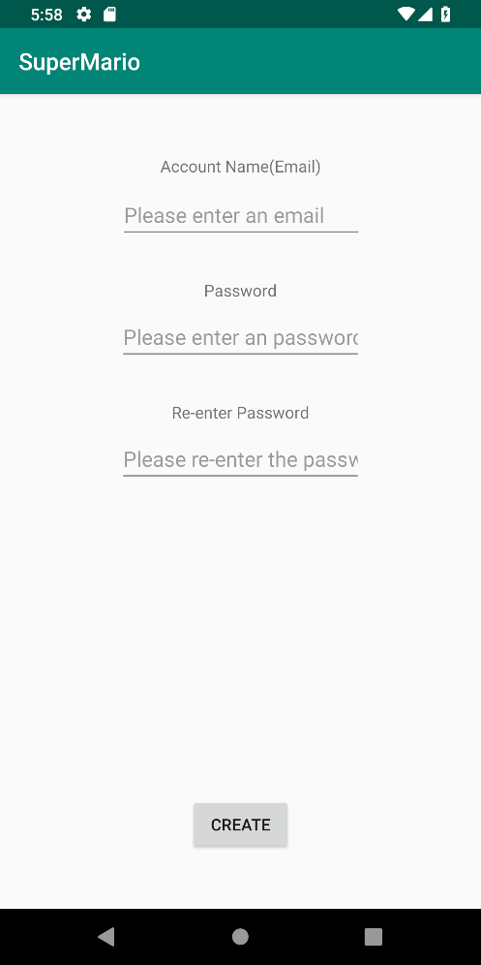

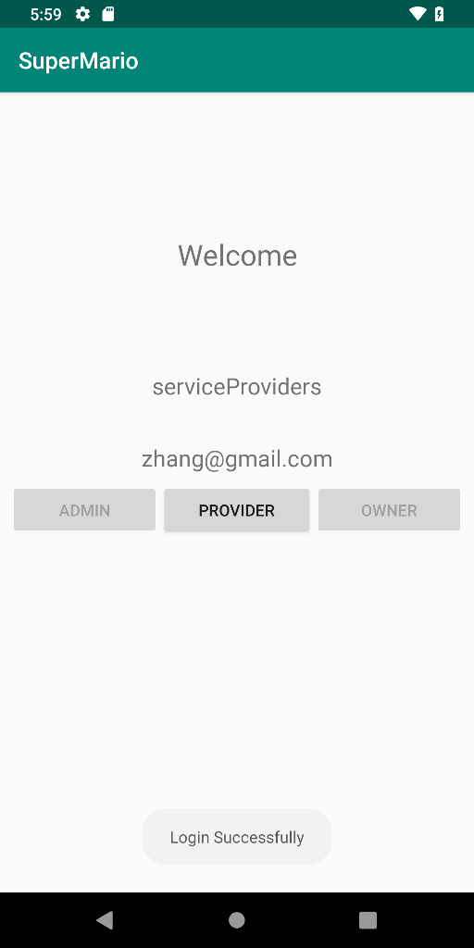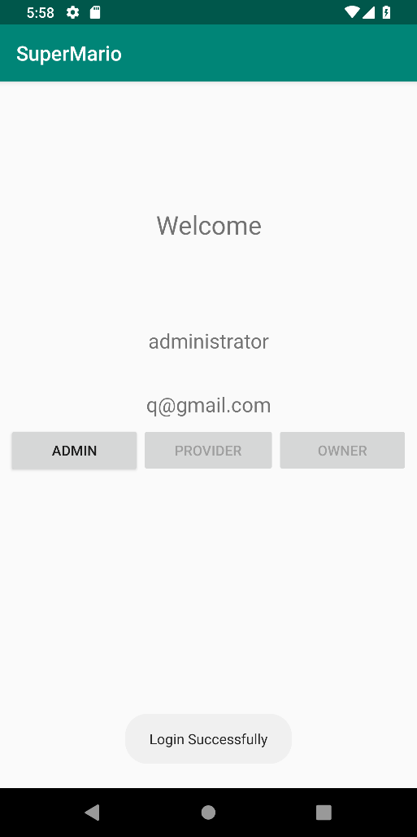

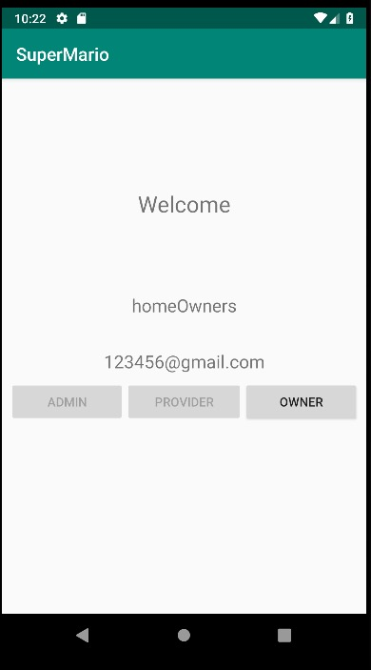

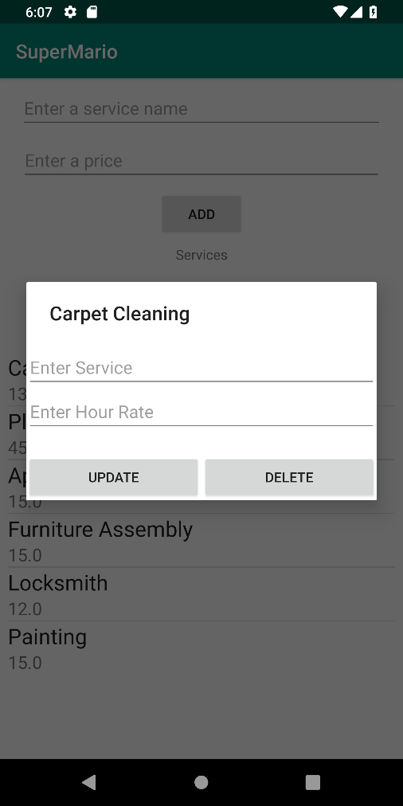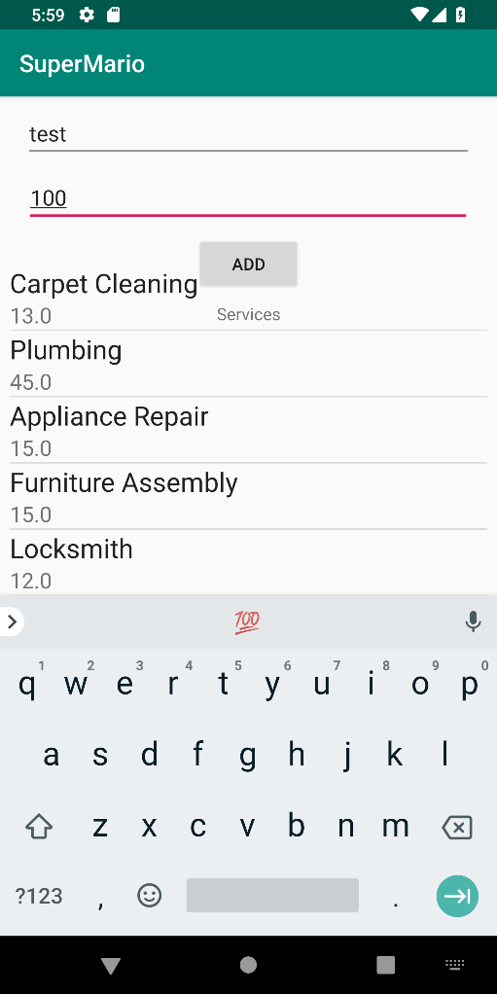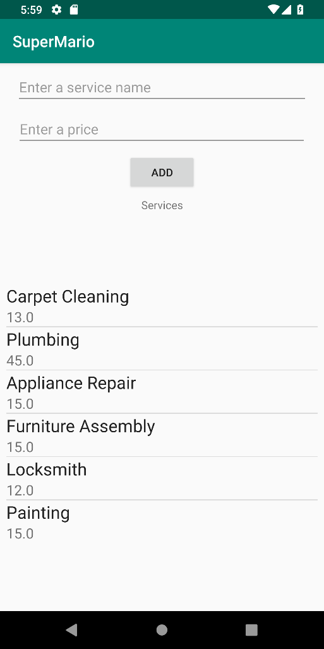

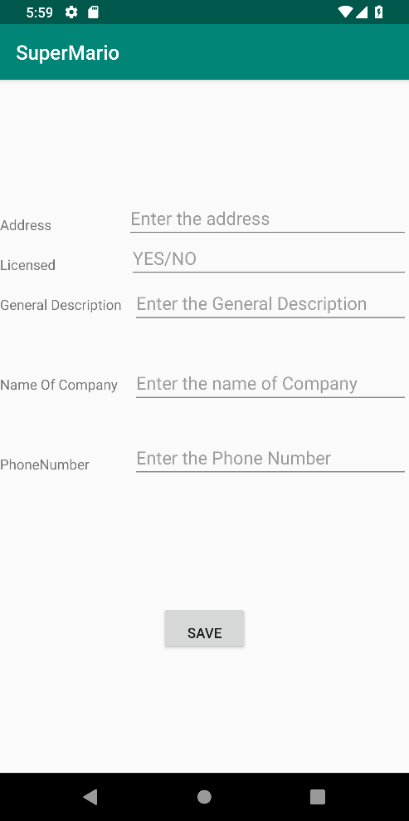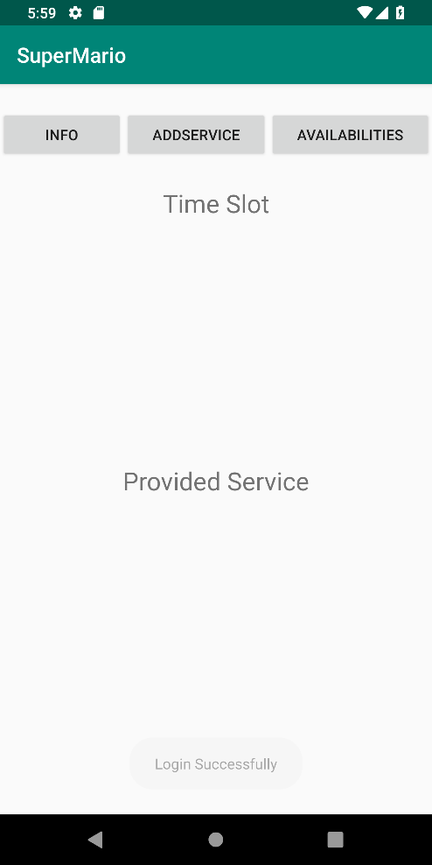

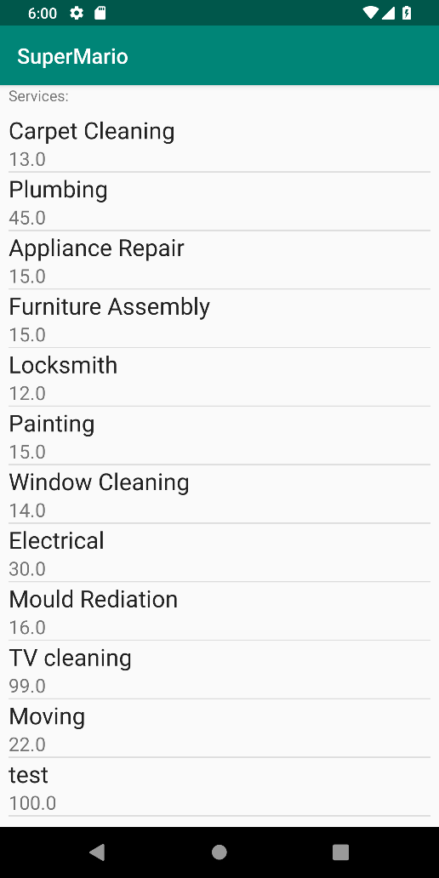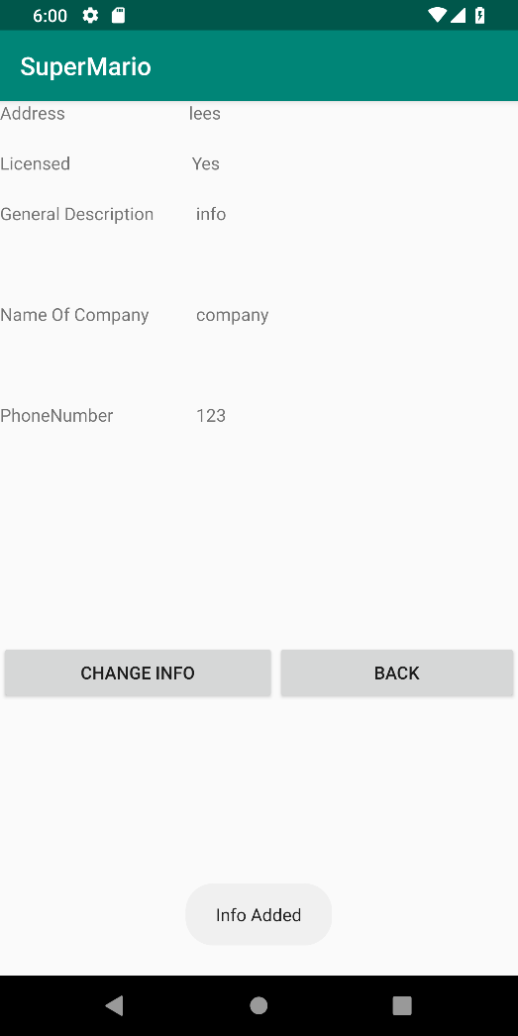

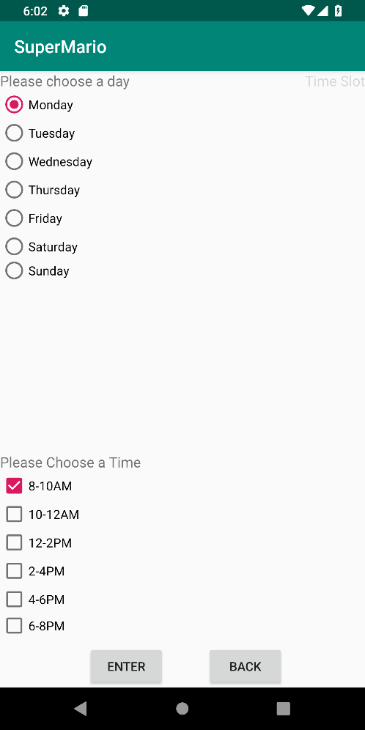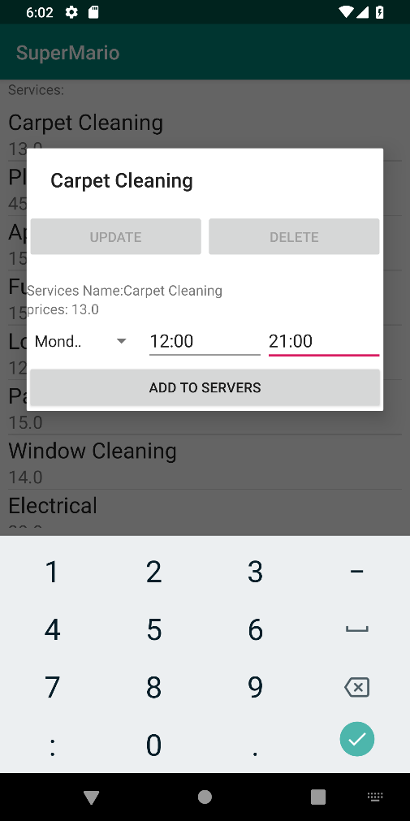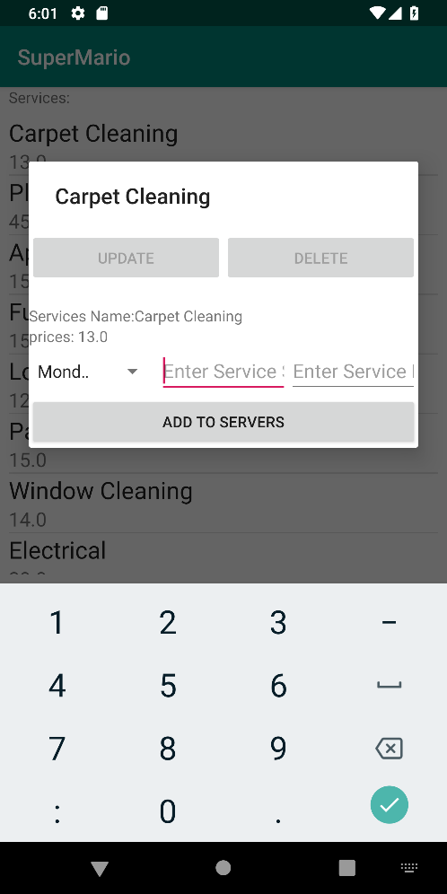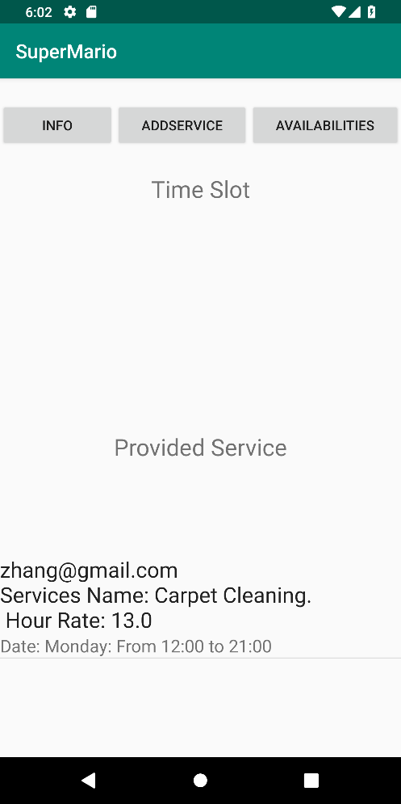

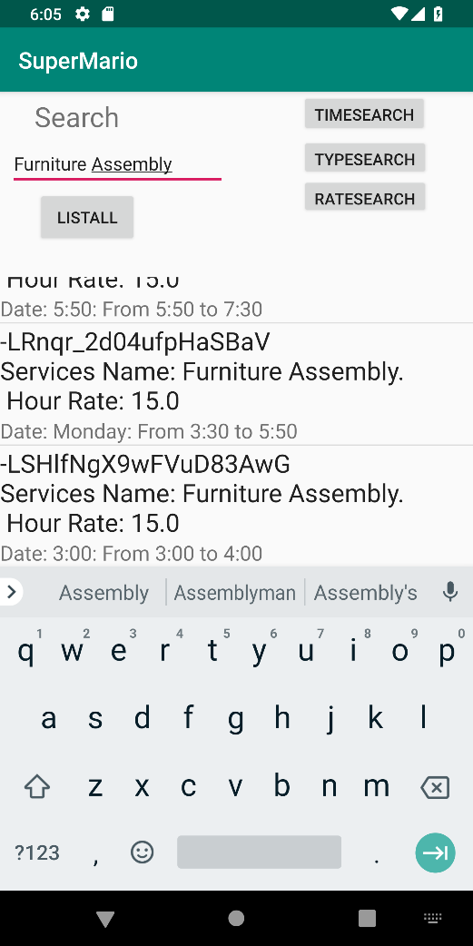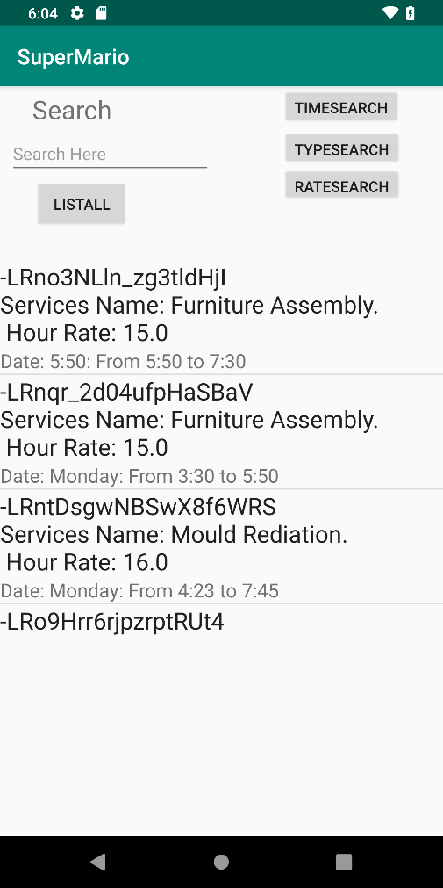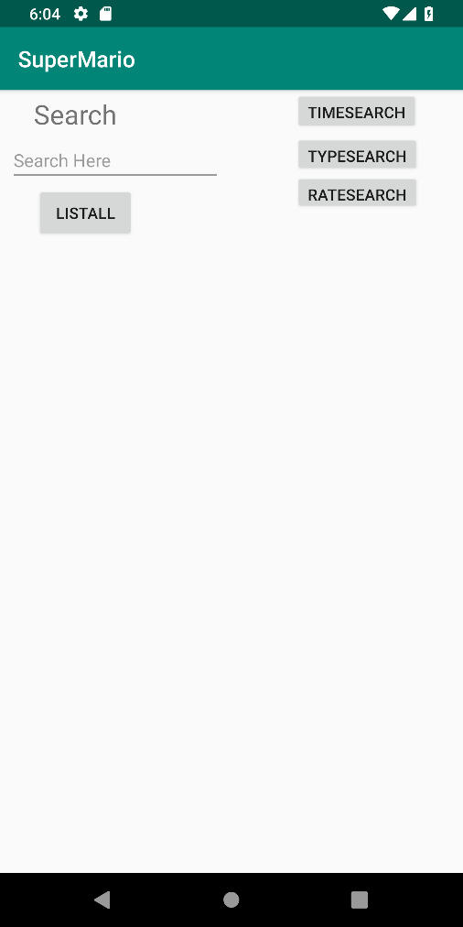

Description of Screenshots:

First page are 4 pics of login system.

Second page are the 3 types of users’ welcome pages.

Third page are the functions of Admin.

Fourth and fifth page are the functions of Service Provider.

Last page are the functions of HomeOwner.